JACK-IN-THE-BOX
ORIGAMI BOX WITH PAPER SPRING
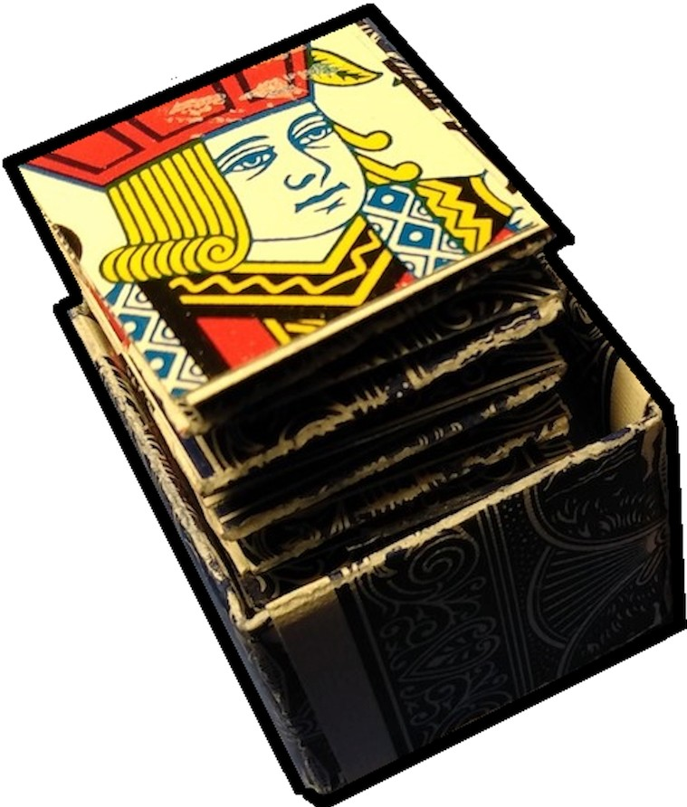
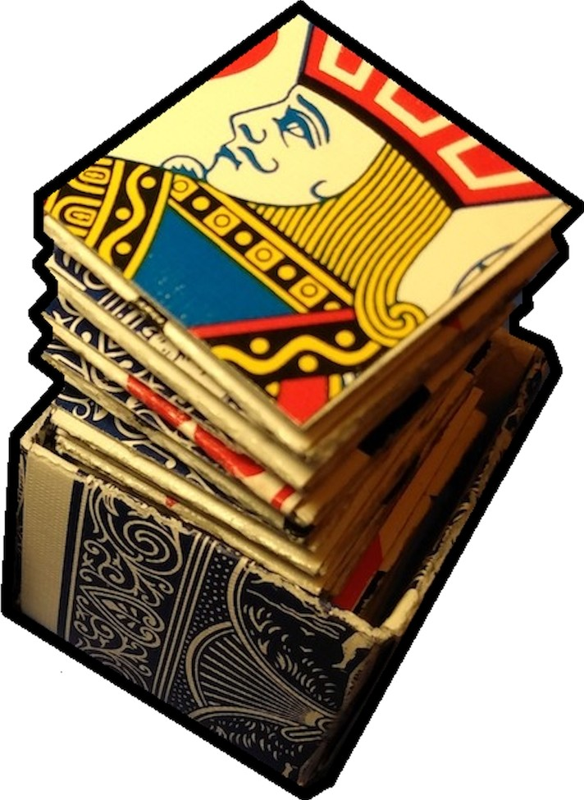
by JAYBERS

Contents:

Box:
Card Fold Instructions
Box Assembly Instructions

Spring:
Card Cutting Instructions Spring Assembly Complete the Spring

Materials: l Jack Card, 16+ Playing Cards, Scissors, Ruler, Super Glue or Strong Craft Glue, Colored Cardstock Paper {Optional)

JCM JAYBERS 2022

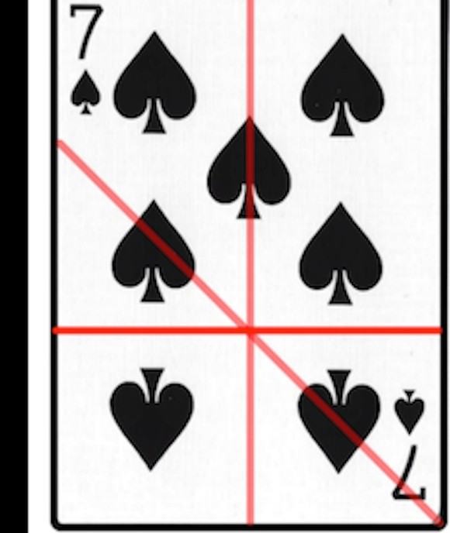
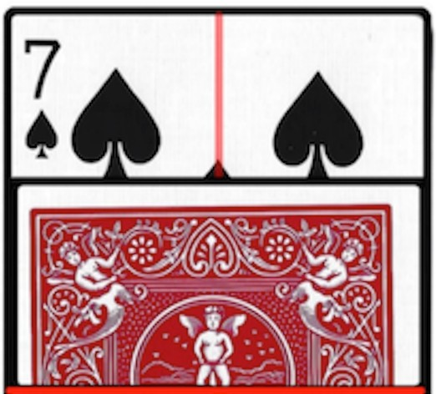
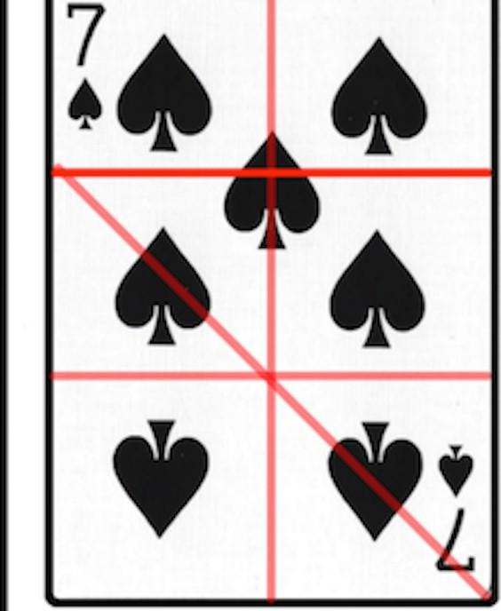
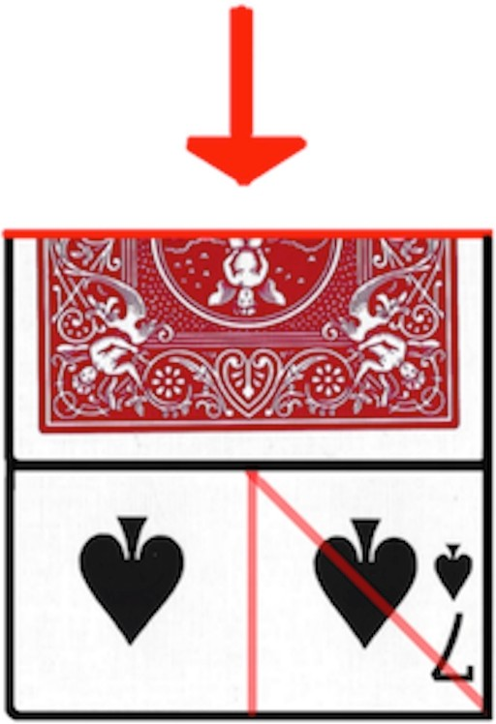
Card Folds
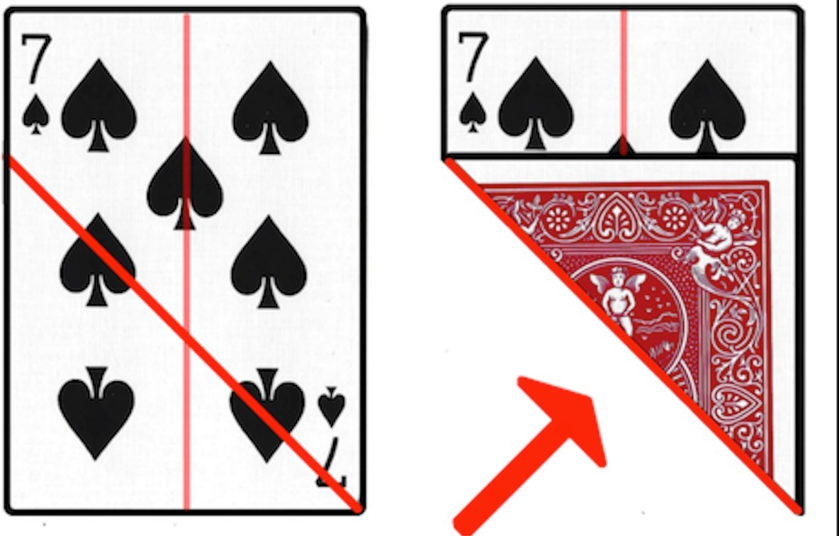
Fold eight (8) cards:

1.  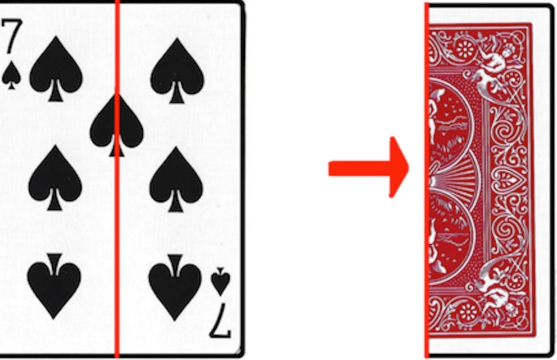 | 2.
3.  i | 4.
5. | 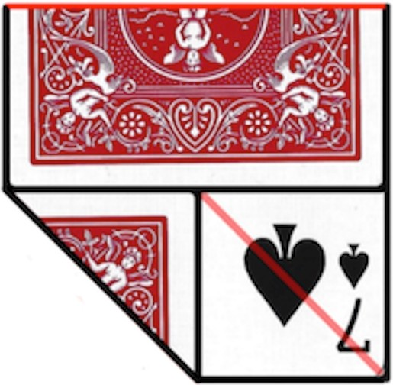
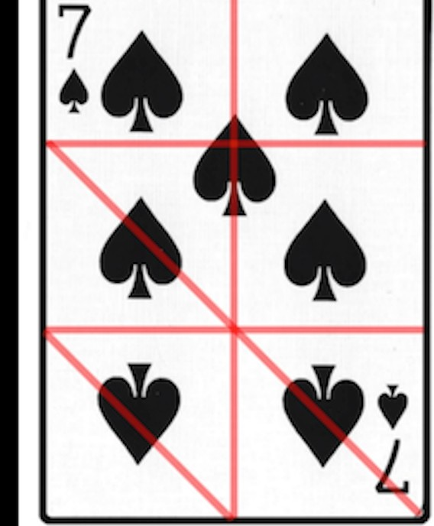
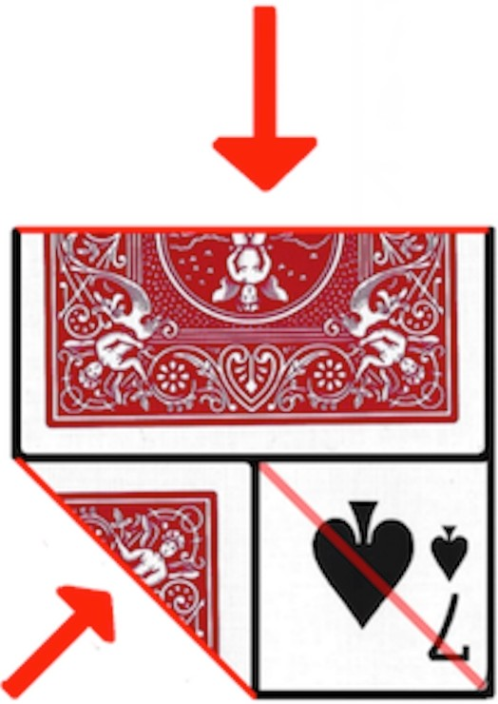
JCM JAYBERS 20 22

BOX ASSEMBLY

Step 1. Modules Fold eight (8) cards
into modules.
These modules will be joined together
to create the base
and the lid of the box.
Step 2. Assembly

Take two (2) modu les , Module 1 and
Module 2.
Insert the left side (X) of Module 2
into the right side 0( ) of Module 1 .
Step 3.

Add a third (3rd) modu le , Module 3.
Insert left side (X) of Module 3
into right side 0( ) of Module 2.
Step 4. Connect Four

Add a fourth (4th) modu le , Module 4.
Insert left side (X) of Module 4 into right side 0( ) of Module 3. Ca refu lly,
insert left side (X) of Module 1 into right side 0( ) of Module 4.
Step 5.

Corefully flip over
the connected pieces.
There are four (4)
corner flaps pointed inward .
Tuck the corners under each other.
Pres s the of the box
to tighten and secure
the modu le s to gethe r.
Step 6. Complete the Box

Assemble a second (2 nd ) box ha lf, The Lid. The other half is The Base .
Open up The Lid by gently pulling apart the
The opening should be big enough to fit over The Base , but not so big that the modules fall a pa rt.
Place The Lid onto The Base , and press the of
The Lid together for a snug fit.
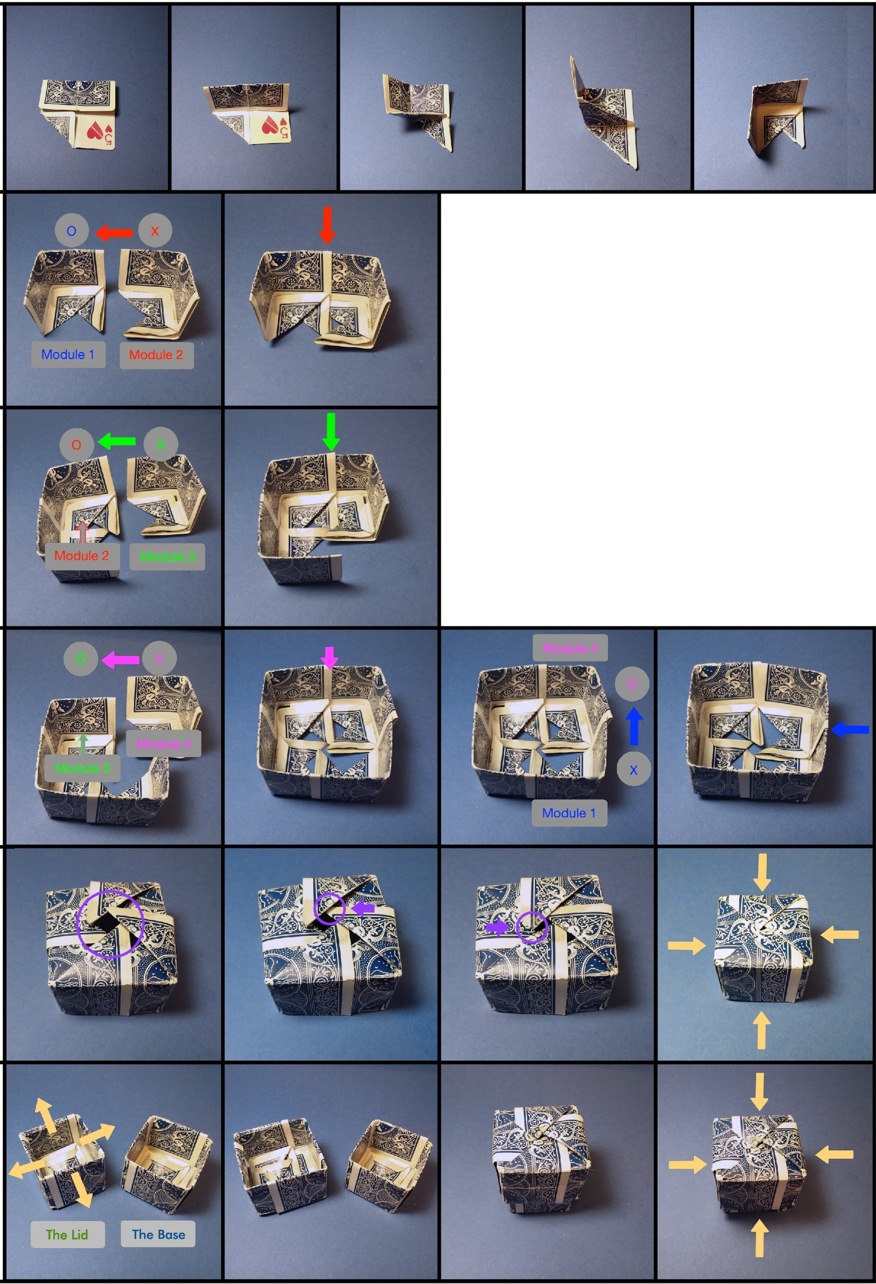
JCM JAYBER S 2022

CARD CUTTING

Playing Card Strips  Cut playing cards lengthwise into  1-inch strips. Around 1 6 strips,  or 8 cards-worth, is recommended. | 1-inch Strips  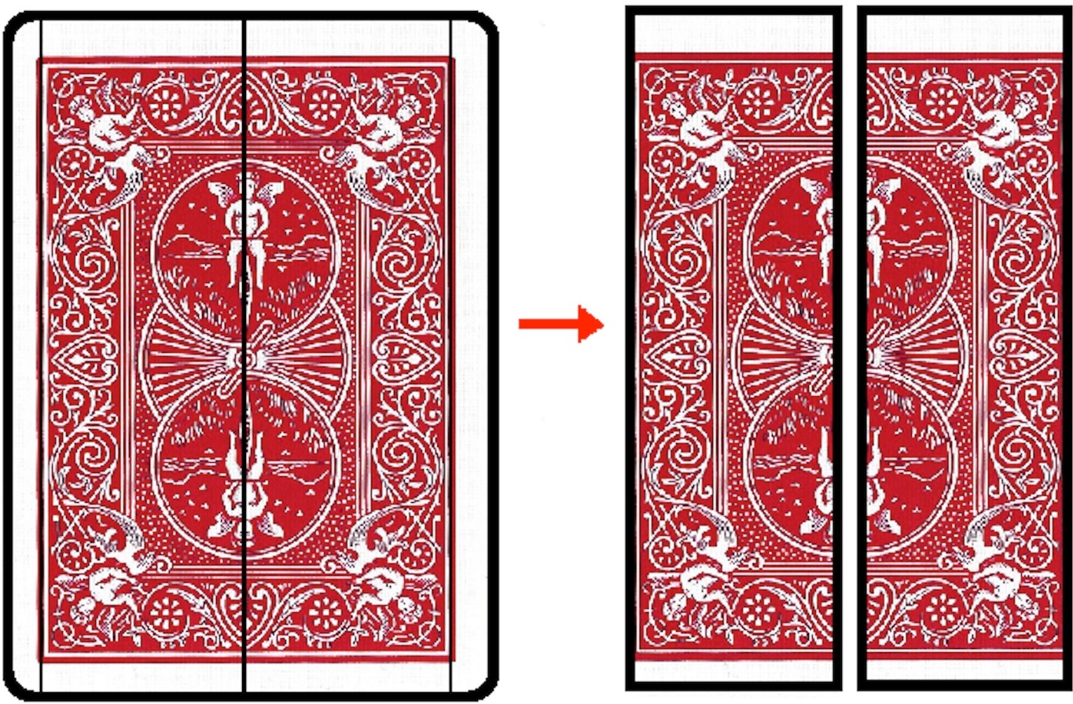
Jack Squares  Cut 1-inch squares of the Jack heads. | 1-inch Squares  ►

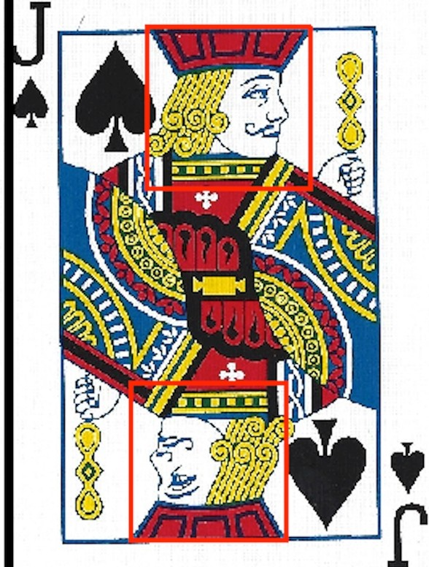
JCM JAYBERS 2022

Spring Assembly
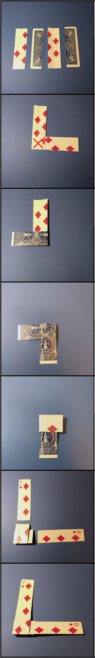
Using 16 or more card strips, create a paper spring.

Glue two (2) strips together at a 90° angle
with the edges lined up. Fold ane aver the other, and repeat .
Glue to extend the strips.
b
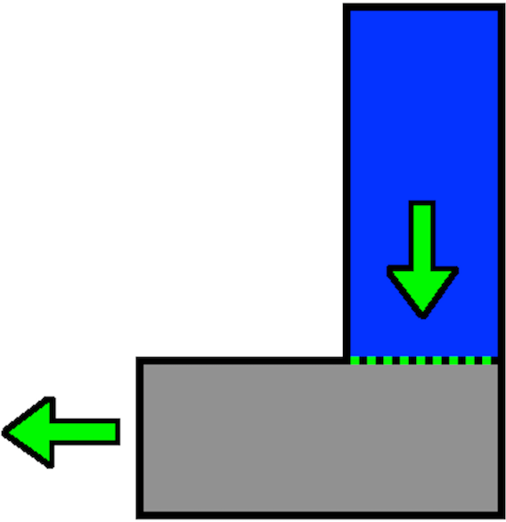
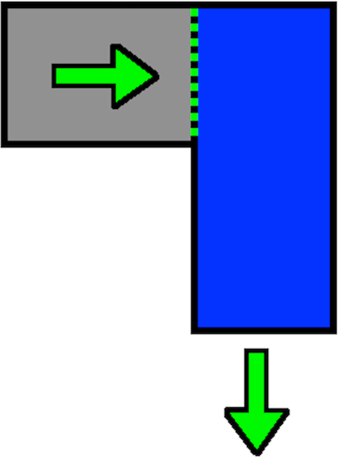
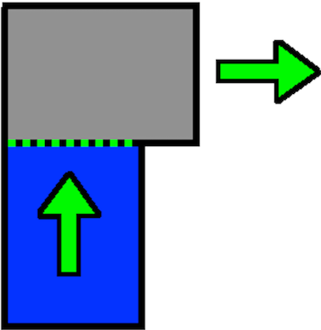

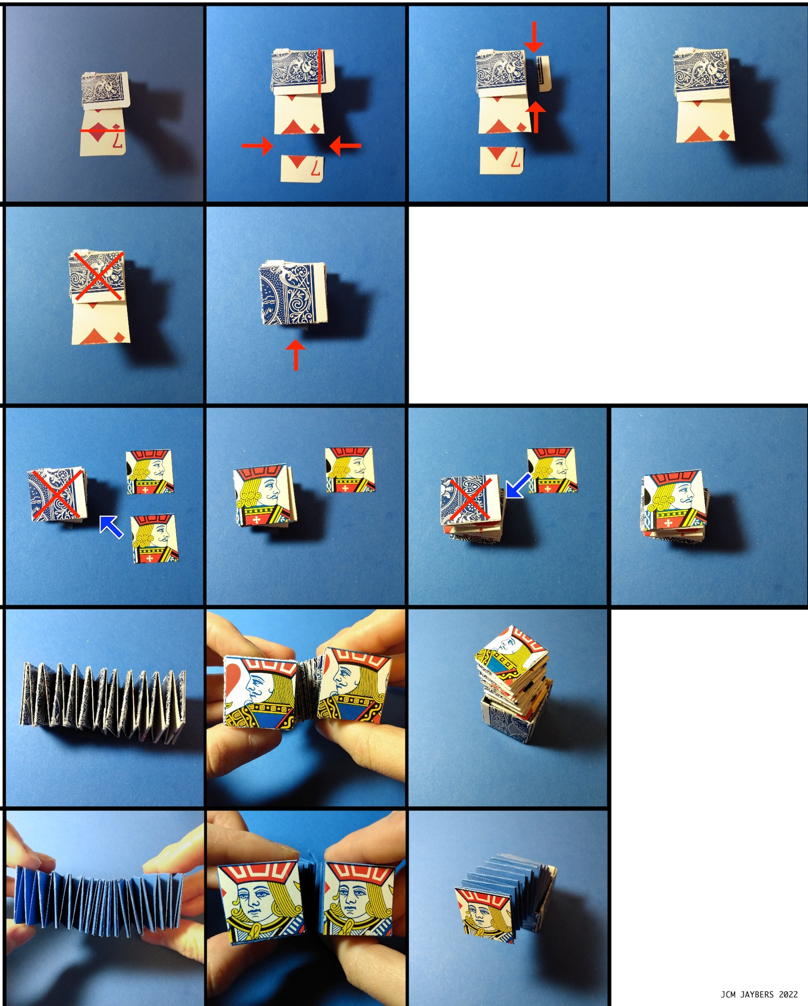Complete the Spring

Step 1.
Fold and Trim

Fold up the last two (2) remaining strips
as far as possible . Trim off the excess at the seam s.

Step 2.
Glue

Glue the flaps together to close the spring .

Step 3.
Glue on the Jacks

Glue the
square Jack pieces onto both ends of the spring.

Final Result

Alternative Result

Try different kinds of paper for varied spring eff ects .

Pict ured :
Light-midweight colored cardstock

